**Project 15: Income Tax Department of India**

**Introduction**

This is the final report for CSE 323 CA-1 by group 15, with members Ritesh Singh, Ratnesh Kumar and Hemendu Kumar. Our project is a functional webpage for Income Tax Department of India, using Html, CSS and Java Script.

**The work was divided among us three in following way:**

1. **Ritesh Singh (12102719)**

**Roll No. RK21PPB101**

Html

{

Homepage

Registration page

Feedback

Forgot Password

}

CSS

{

Homepage

Registration page

Feedback

Forgot Password

ITR Status

E-Verify Returns

}

Java Script

{

Homepage  
}

1. **Ratnesh Kumar (12113859)**

**Roll No. RK21PPA53**

Html

{

Login-Submit

Instant E-Pan

Submit Tax

ITR Status

E-Verify Returns

Contact Us  
}

Java Script

{

E-Verify Returns

ITR Status  
}

1. **Hemendu Kumar (12102822)**

**Roll No. RK21PPB100**

Html

{

About The Portal

History

}

**Objective**

To Create a webpage of Income tax Department of India using HTML, CSS and Java Script, within the limits of given structure. The site should be function and consisting of sub pages linked to it. The following is a group task and is to be done accordingly.

**Flow Chart**

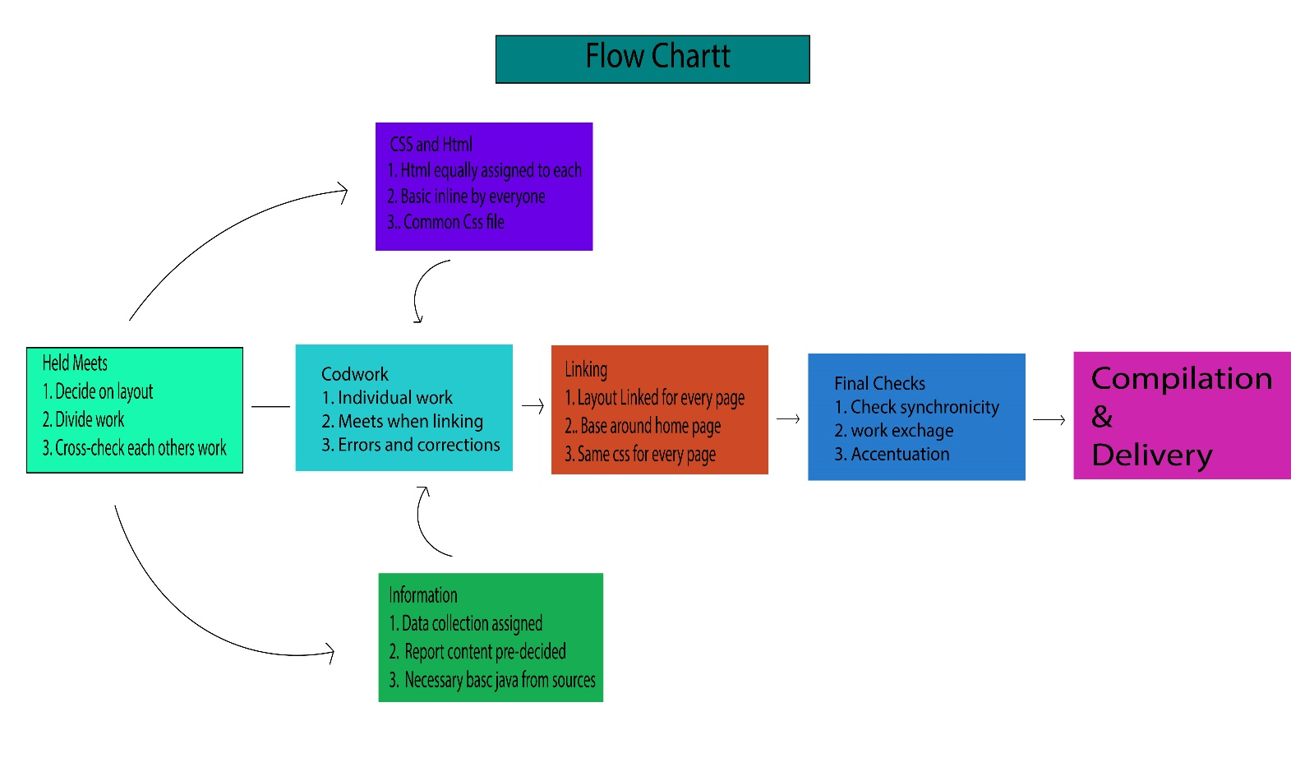

**Individual Reports**

1. **Ritesh Singh**

**HomePage:**

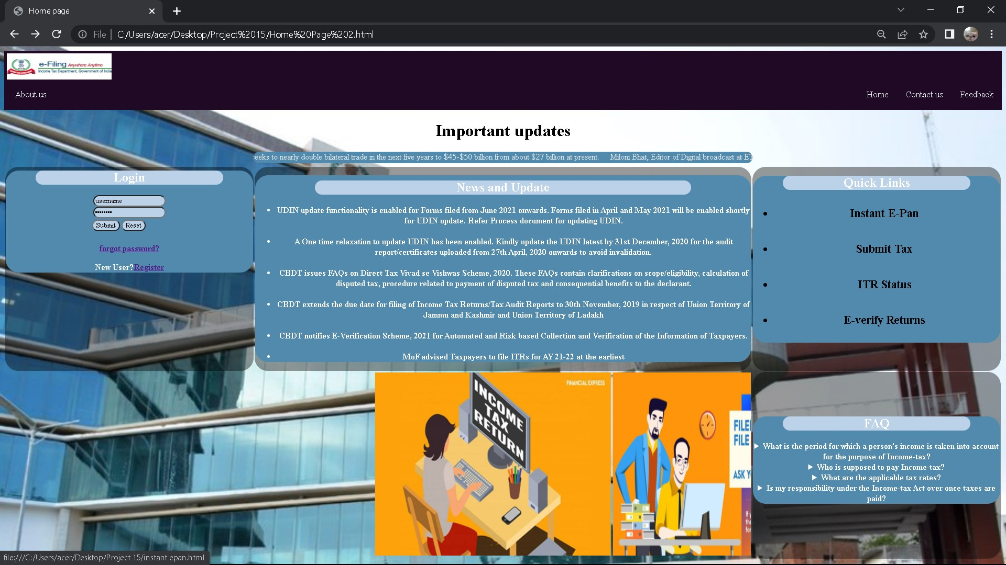

For homepage as well as all of the linked page a single css file is use. The home page consists of a header with Symbol and linked blocks to jump to Home, Contacts, About Us and Feedback. A dropdown is used for About Us.

Between Header and Table there is a small box with moving text of important updates.

In table first row has three columns with login box, news and at extreme right a quick links. The second row has 2 columns with one on left showing images related to sight in a slideshow using marquee. And the right one is Frequently Asked Question, where details and summary was used.

**Forgot password:**

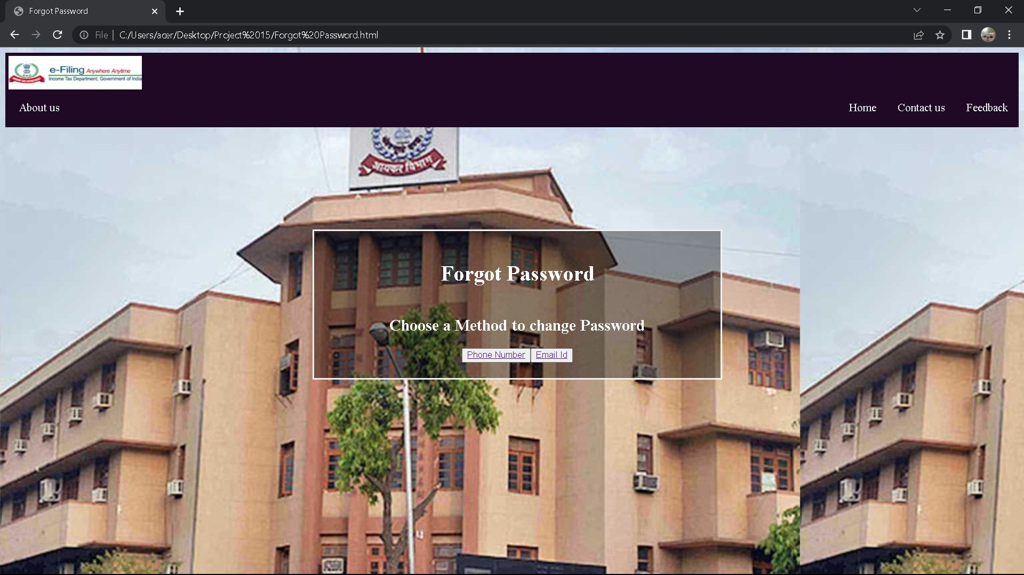

The header stays the same as home page, this page is linked with forgot password in home page and is solely for the purpose of recovering password. It uses two pseudo button which is usually seen in such pages on web.

**Registartion Page:**

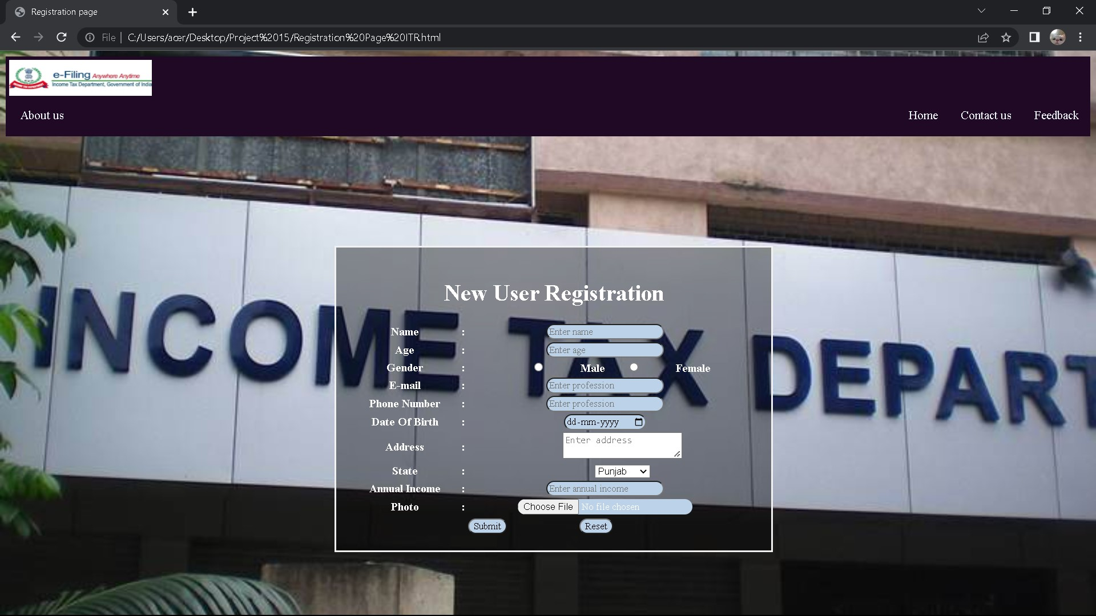

With the same header as home page, this sub page contains mostly forms to take data from users, which may be text,file,image,date,email etc.

**FeedBack:**

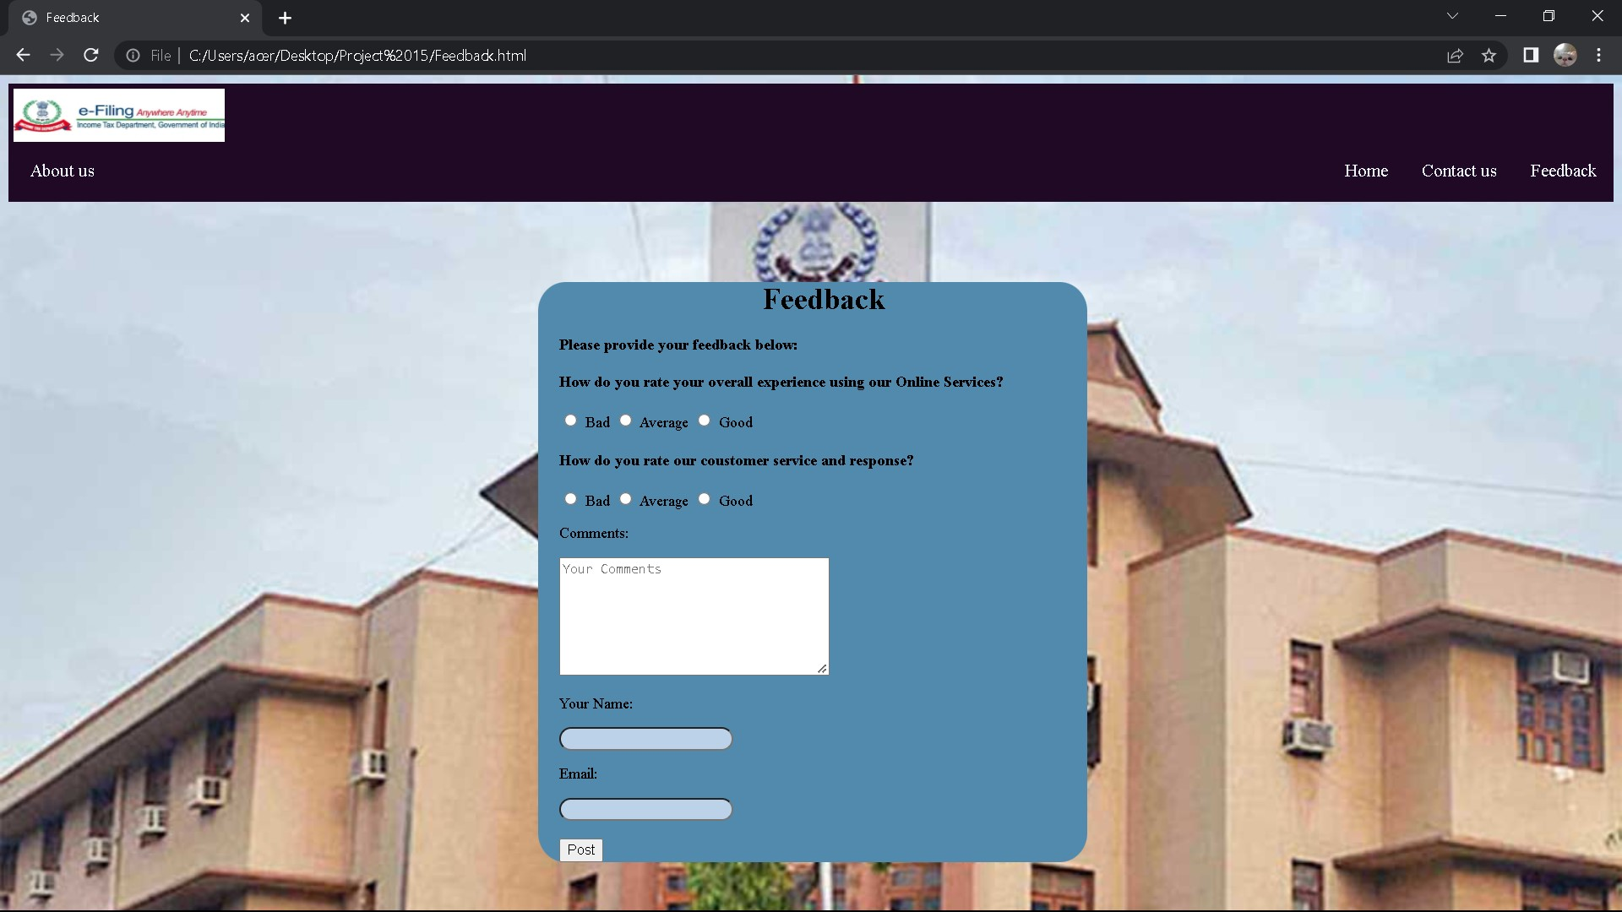

Same header as home page, this sub page uses internal css to avoid clashing class names and id. It contains forms radio button etc and is only meant for taking data.

**2. Ratnesh Kumar**

These works were done by Ratnesh Kumar (12113859)

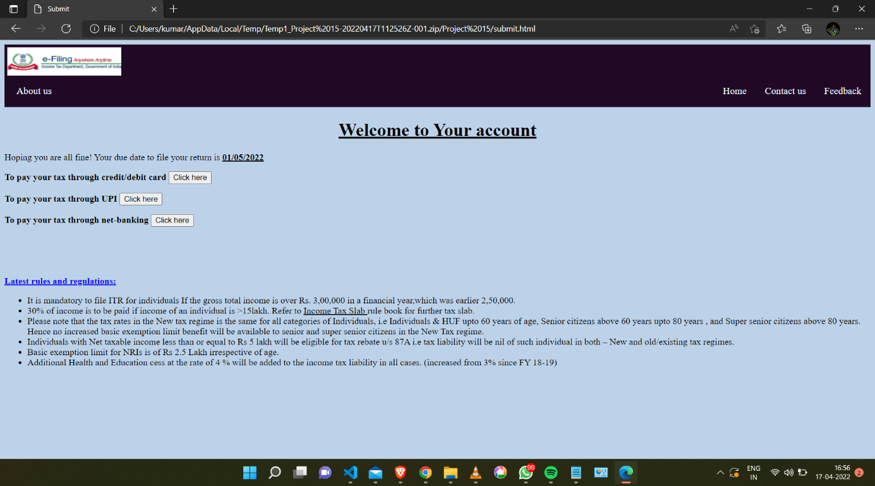

This is a login page where the user will get redirected after he/she submits his/her login credentials. This webpage contains options for paying taxes through various methods, We have used button tag for creating “Click here” button. Syntax: <button type="button">Click here</button>. Also we have added some rules and regulations of Income Tax Department which every used should know.

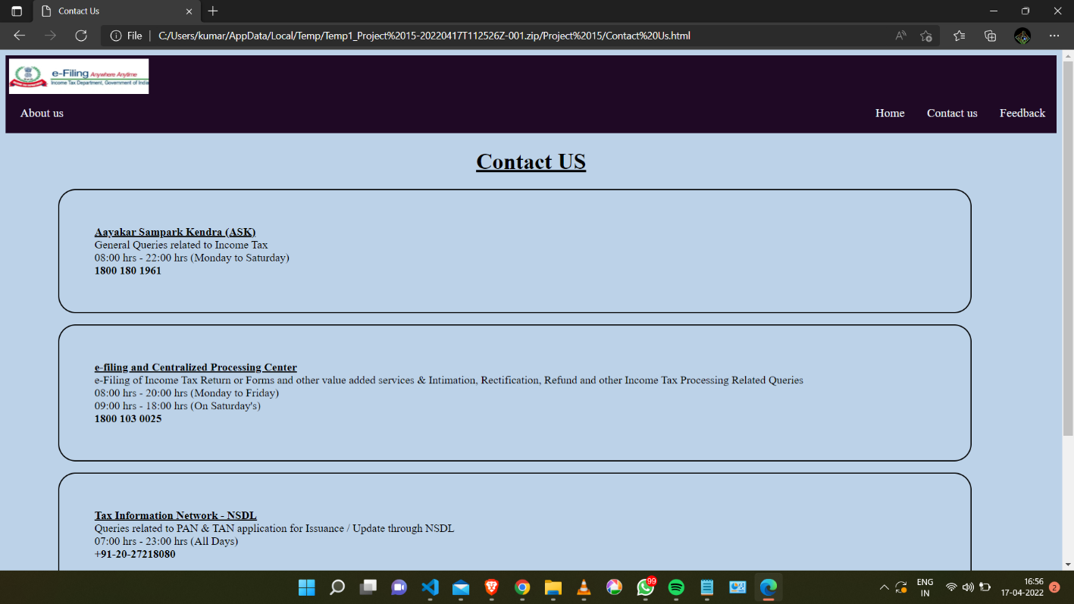

This webpage will basically help to easily find the contact details of the concerned authority to which a user want to get in touch with. In this webpage we have created a box model in which we have added texts.

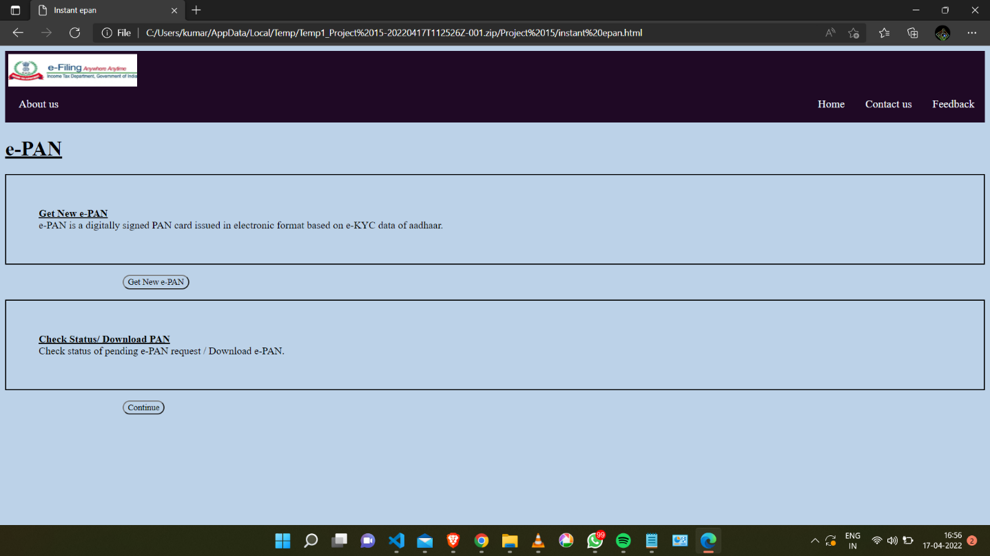

This is a webpage which will allow the user to apply for their new e-Pan or to get the status of their applied e-pan. This webpage is nearly similar to previous one as same box-model and button tags are been used in it.

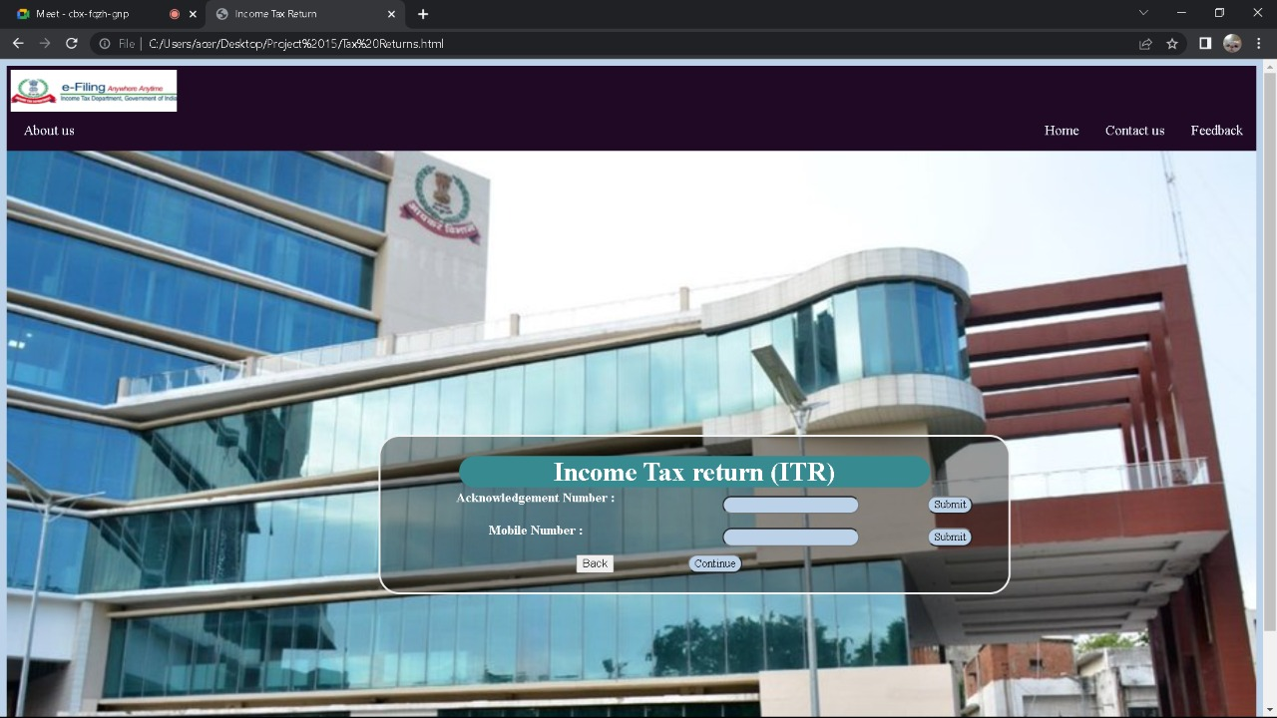This webpage will allow the user to submit their tax, So at first the user will submit their credential for the verification purpose. In this webpage we have created a form in which we have added data and since we have not created further webpages which should be redirected after clicking continue button so we have basically created a extra webpage show “ This feature is not available”. We have linked that button by applying and external link and linked that with concerned buttons.

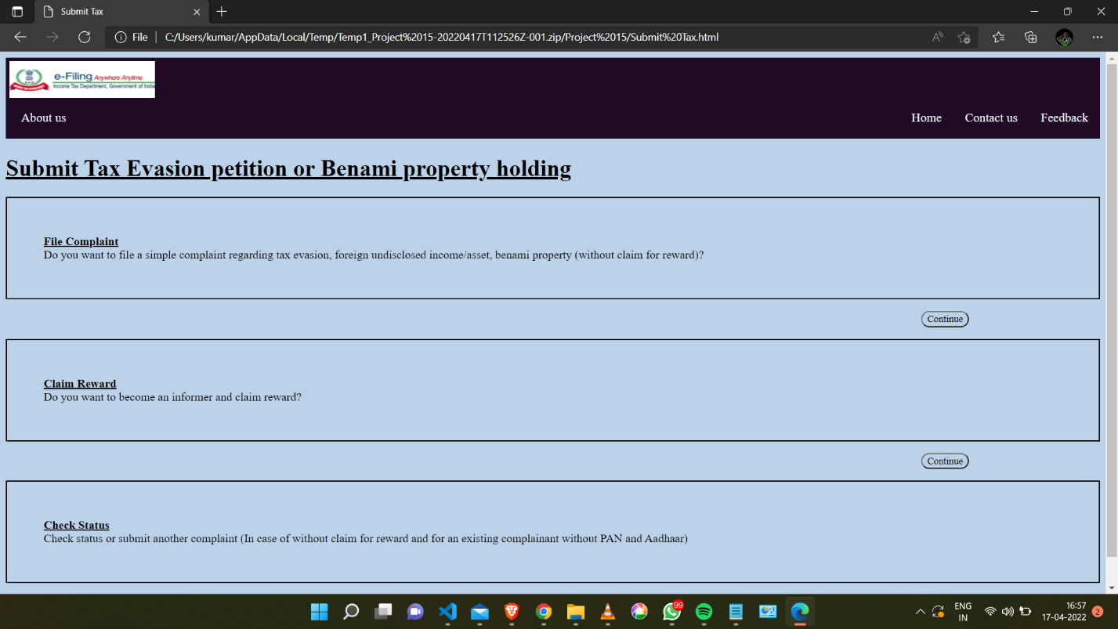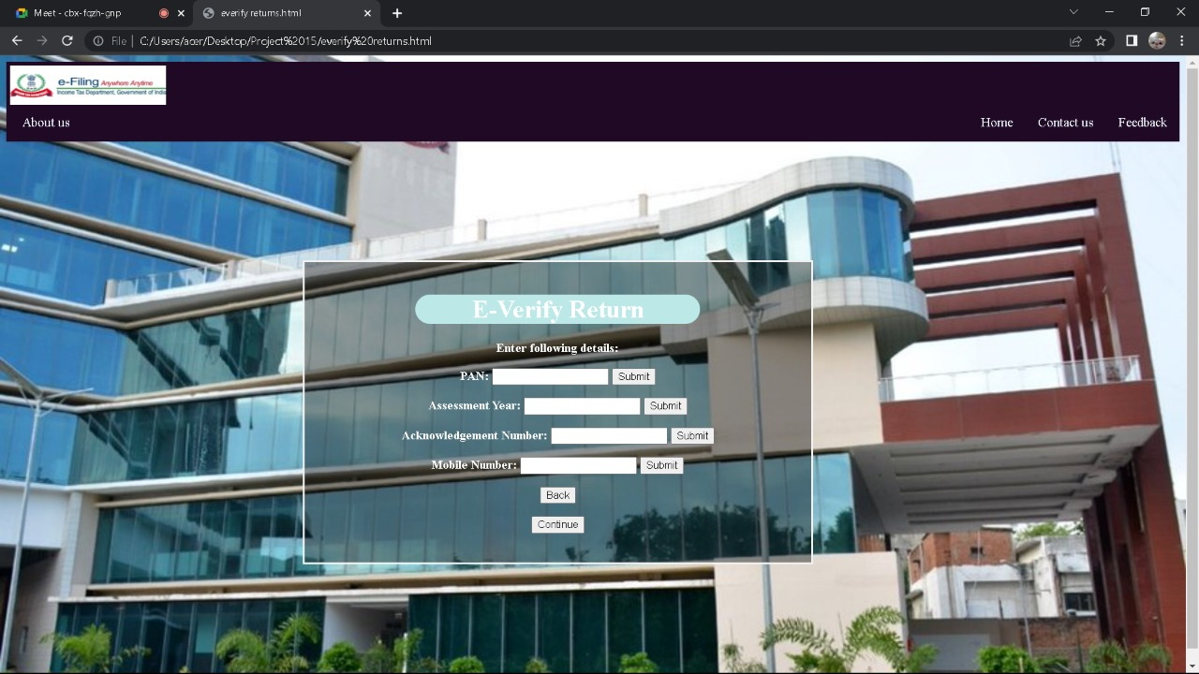This webpage will allow the user to file their complains and to claim rewards after they pay their taxes and check status of their filed complain. This webpage has basic CSS applied as this has just box-model and buttons whose syntax are already explained.

This webpage will allow the user to file their return as the user will get verified as he/she will enter their details of PAN, Mobile number etc. In this webpage we have created a form in which the user will get to enter their details and these all are done in a box-model.

**2. Hemendu Kumar**

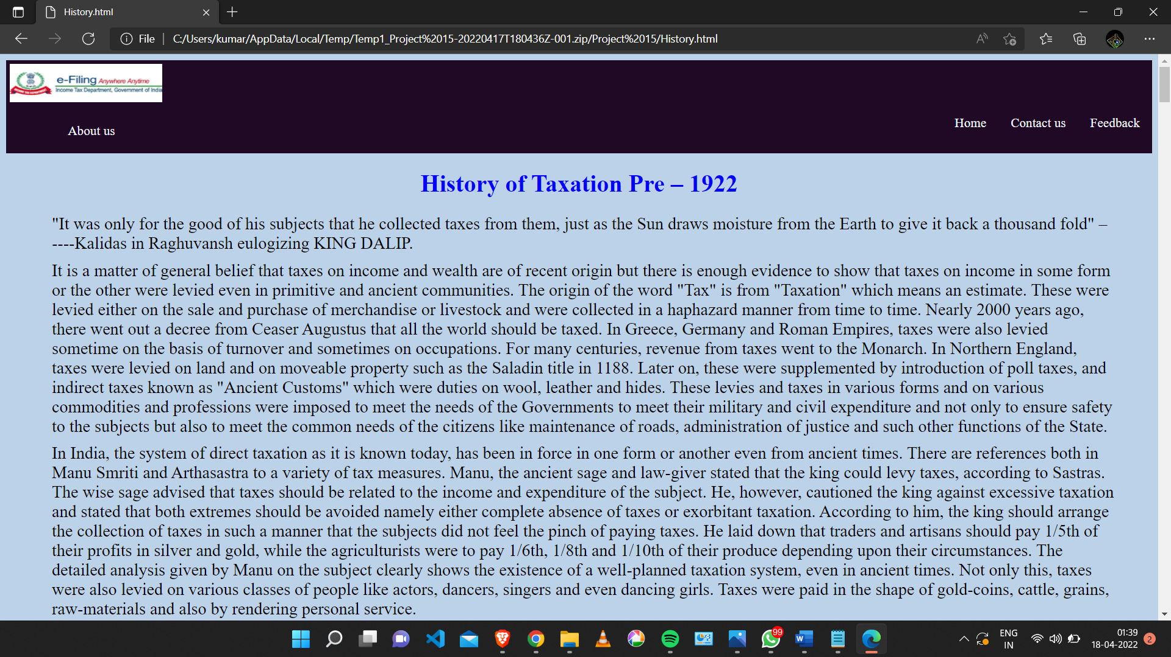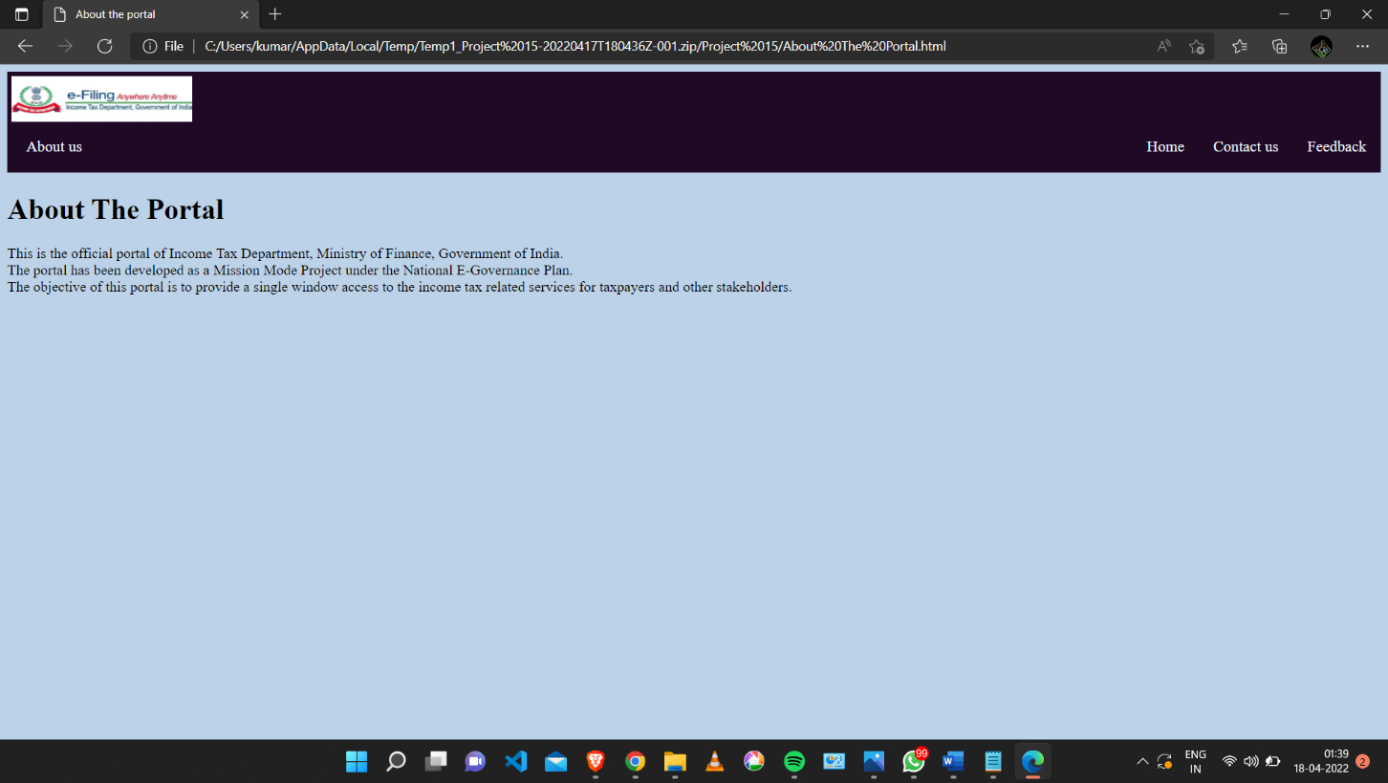This is the webpage created so that the user get to know about the portal.

This webpage is basically a history of Income Tax Department. This webpage is created so that the user will get to know about the history of IT. These data were collected from official IT department portal.

**Conclusion:**

The project was completed in due time and to our expectation with all the intended functionality and visuals. It was a great learning opportunity to apply the learnings of both class and what all we can explore on the internet.

Putting together different elemnts and tags to create something useful and at the same time making sure that it looks good, this project allowed us to aplly ourslelves and go all out in creating the best imagined webpage we can within the given structure and topic.

**Future Scope**

Alhough our project is very basic with little to no real world use at the moment but it has the potential to be uprgraded with the depth of Web development and the backend. It has scope to be used in finance managemnt for smaller firms if the source code is stripped of the earlier required pages. Given that most tof the functionality ould match the required are of use, it has scope to be further developed and be of value.

**Refrences:**

* Class Recordings
* W3 Schools
* Youtube
* https://freecodecamp.org
* https://eportal.incometax.gov.in